1. No response after 50 minutes as advertised; over 2 hours still no response

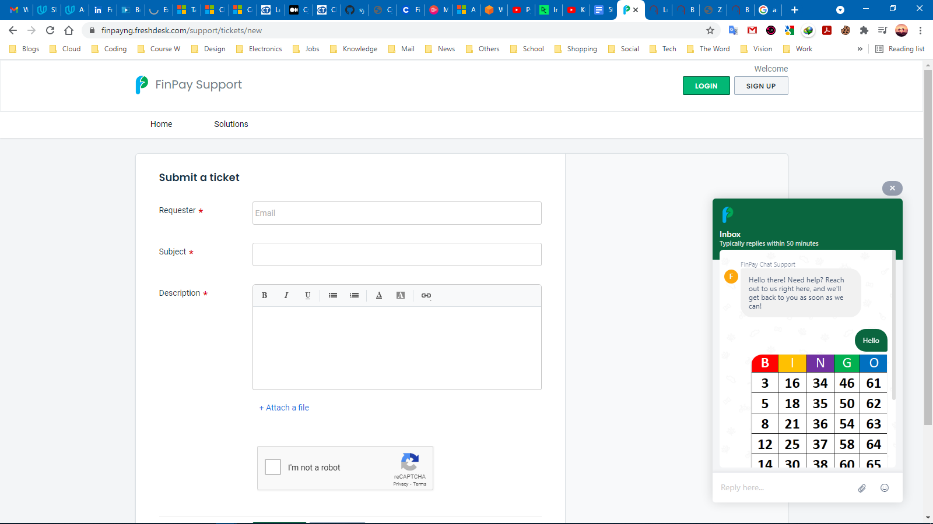

1. © not updated to 2021

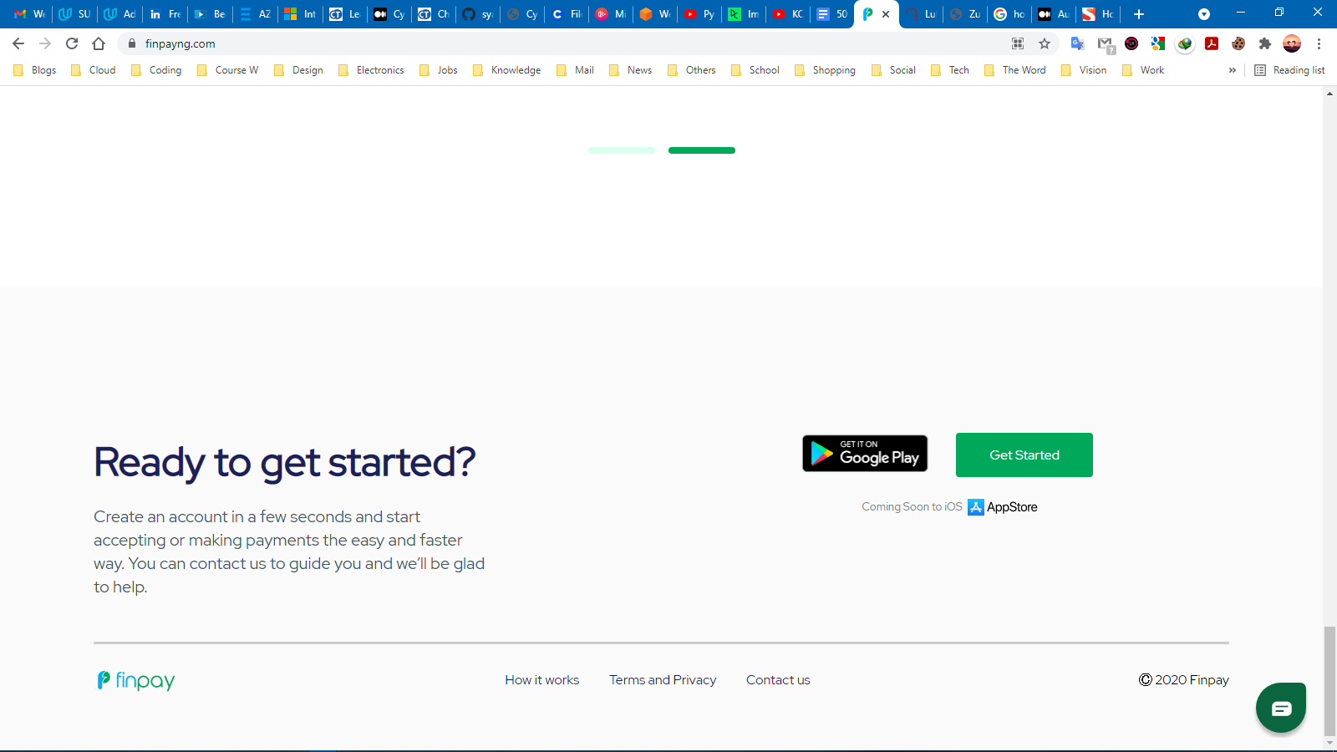

1. Missing image for mobile app download

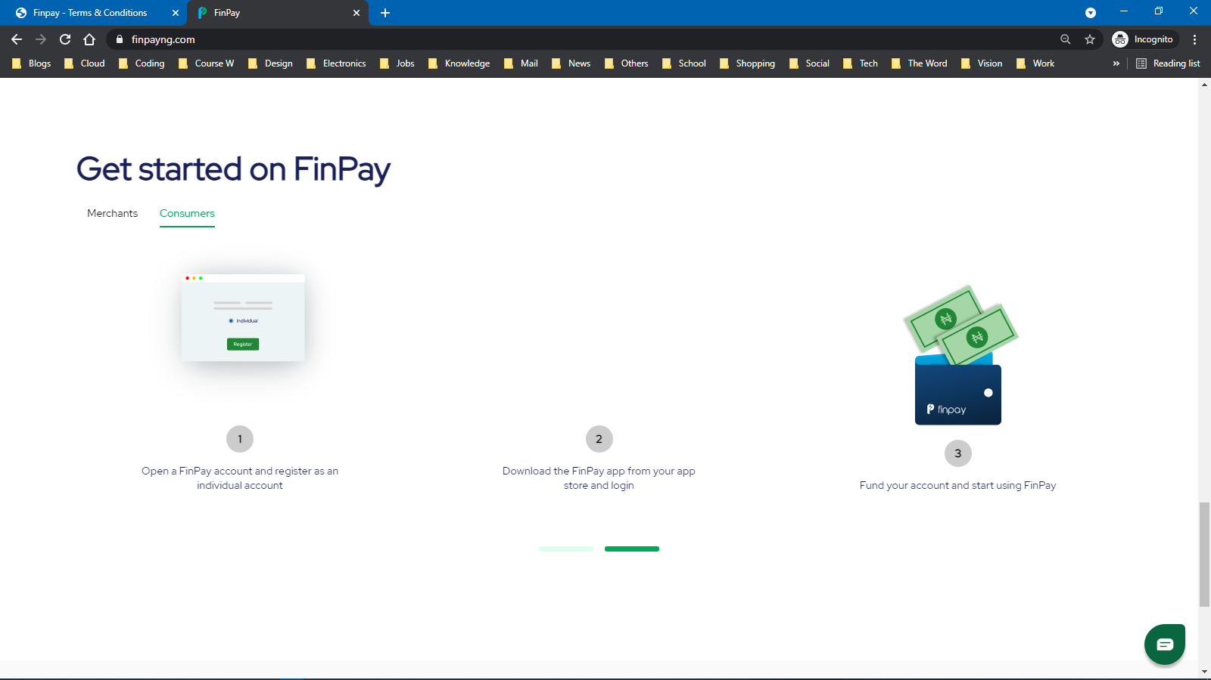

1. Should be able to click on the logo and redirected to the home page

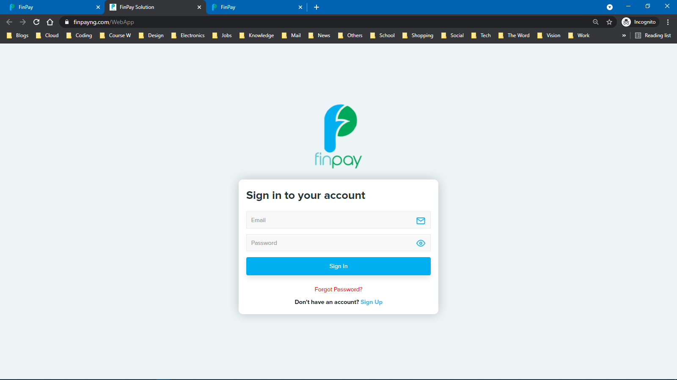

1. Why are some written in capital letters and others in small letters?

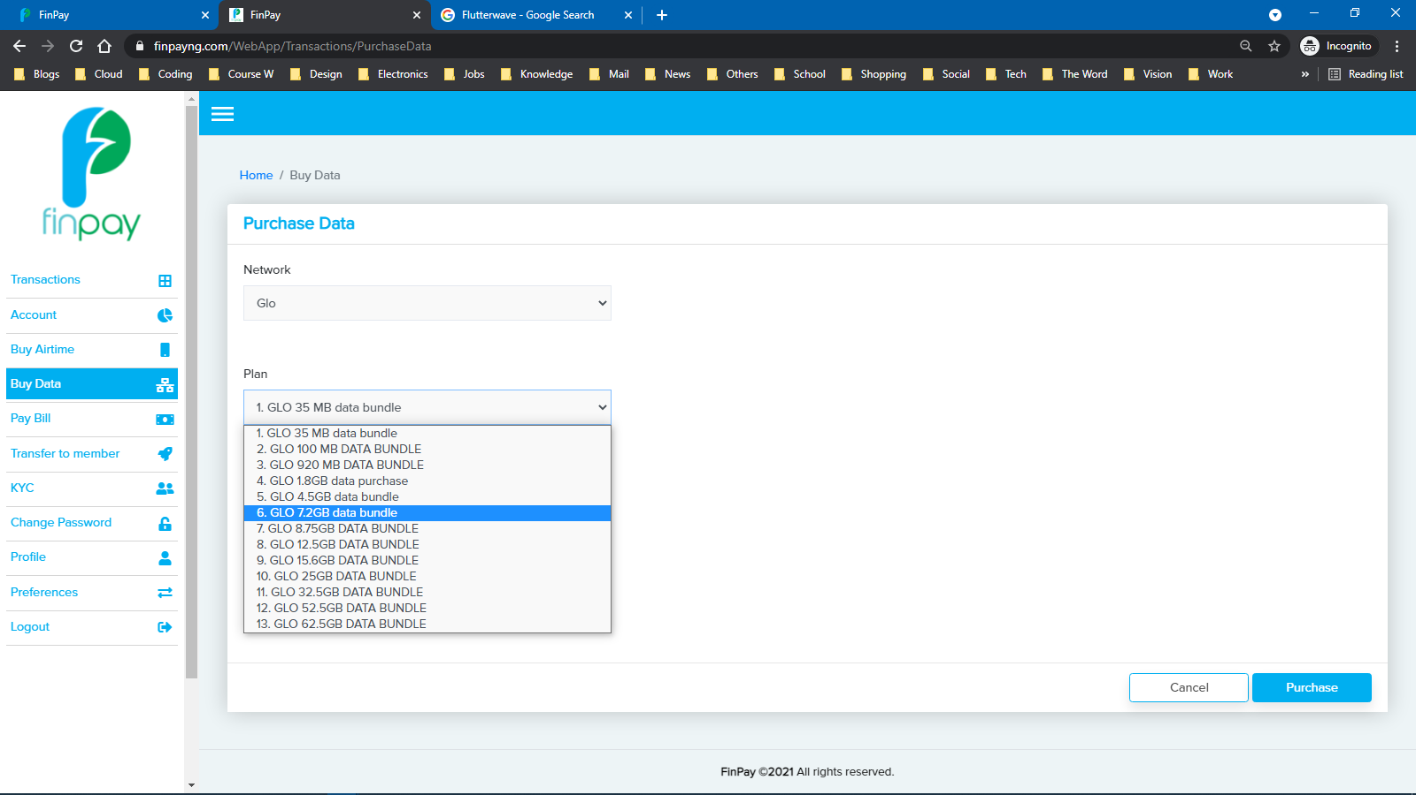

1. Can we have subsections for daily, weekly and monthly data plans?

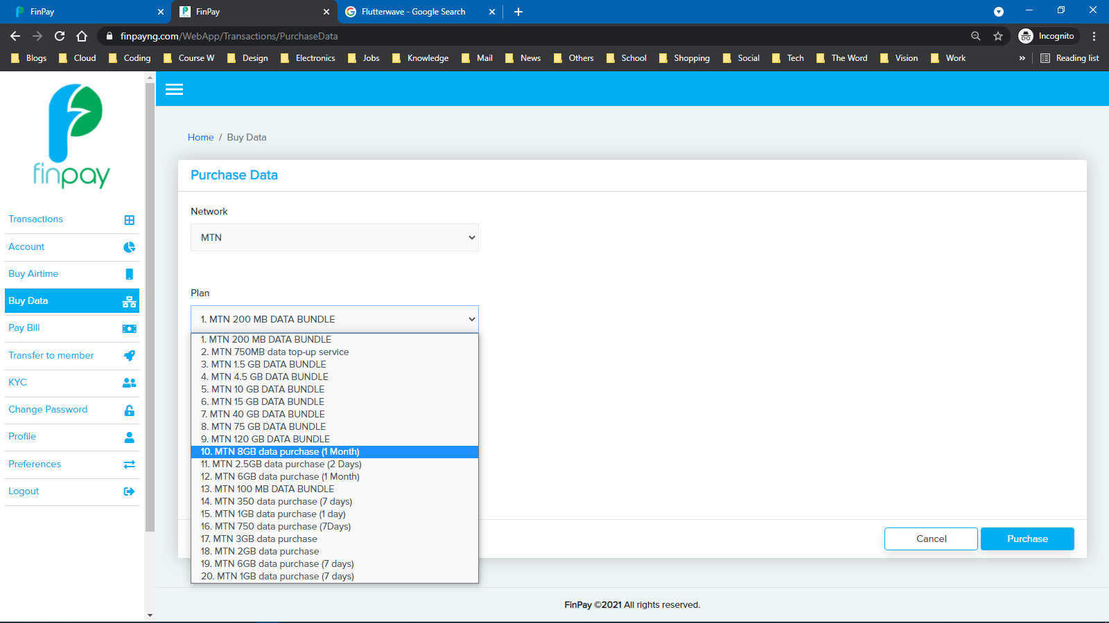

1. Why is the internet on Smile written with capital letter “I” whereas that on Swift is written with small letter “i”?

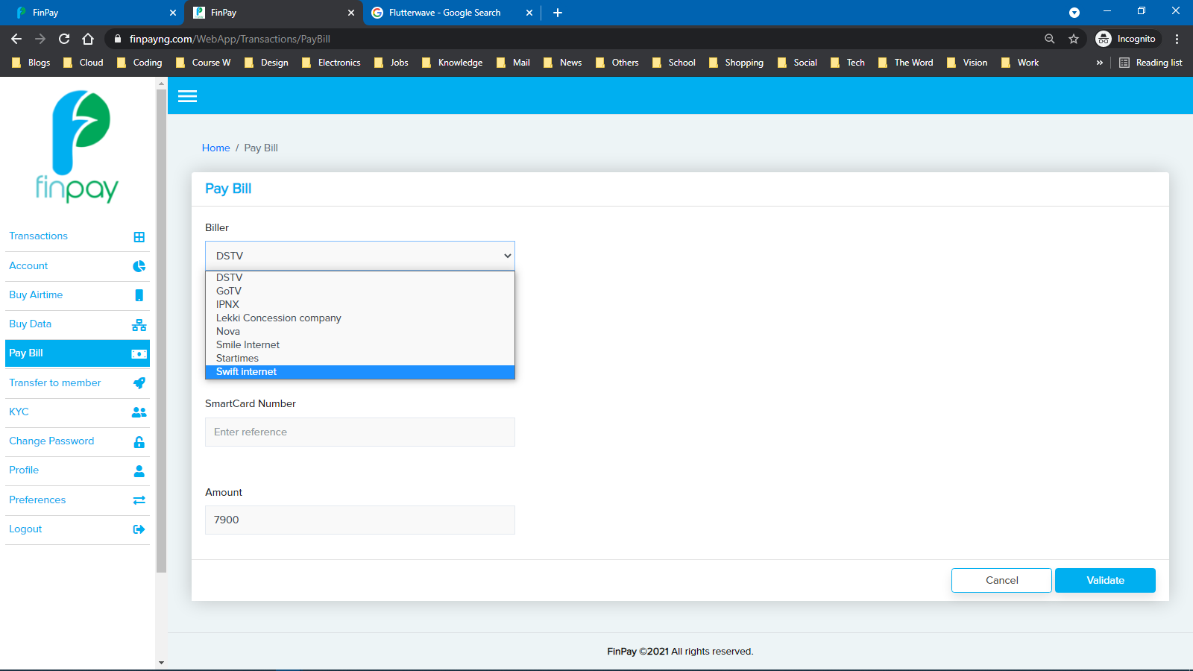

1. Why not stick with one font style? Don’t mix and match

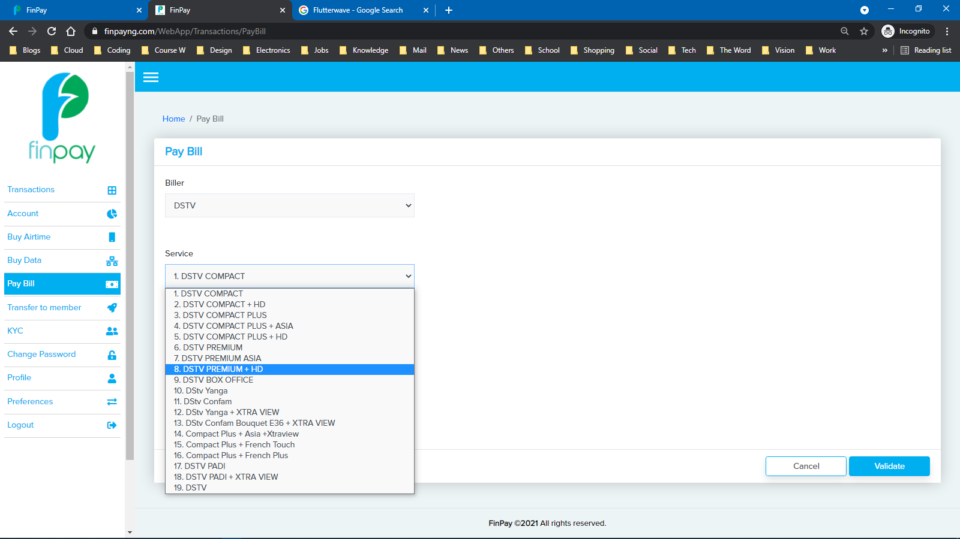

1. SMS notification will also be useful

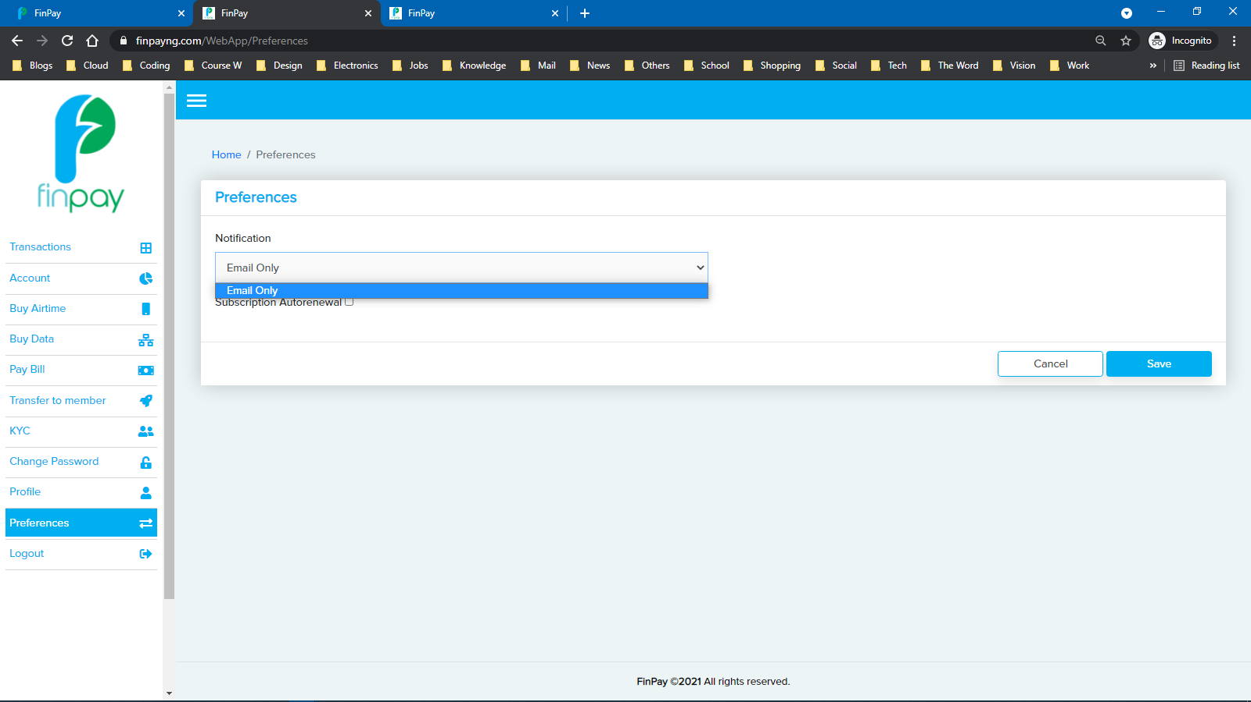

1. I should be redirected to the homepage after clicking on the “finpay” icon or the footnote.

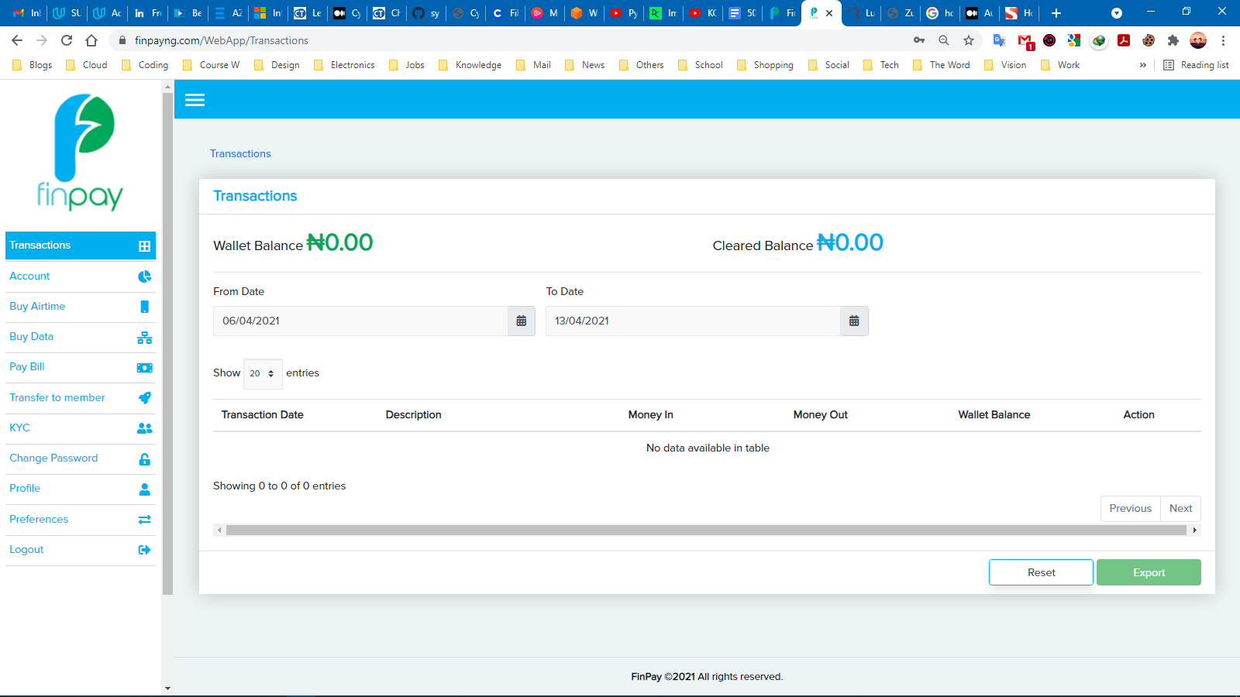

1. Having a “Welcome or hello, my first or last name message” at the top left or right-hand corner like the example below will make it more personal and meaningful to the end user.

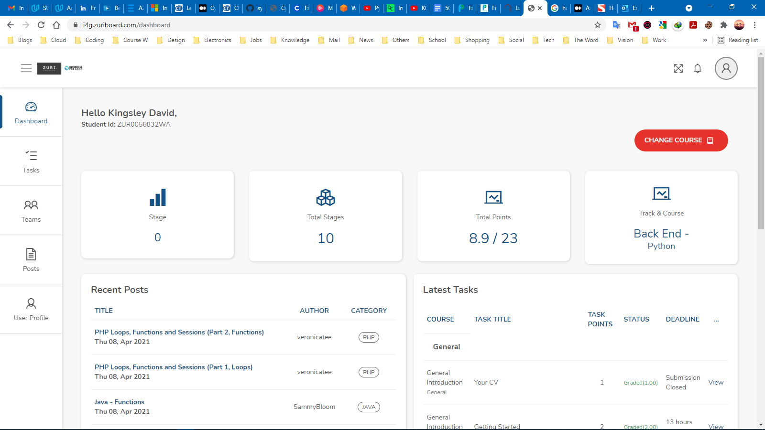



1. No option to deactivate account. What if I am not satisfied with the service or I no longer feel comfortable using this service? I should be given the option to walk away.

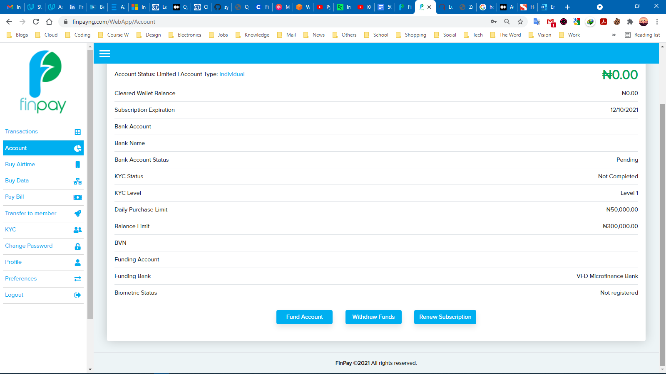

1. Since we’re testing this website, we should have been given dummy credentials to both signup and login with, and not have to use our own legal identities to do so. Also, we should have money in our accounts (this is where the dummy identities come to play) so we could test the deposit and withdrawal functionalities of the site – since it is the key essence of the website.